GREATER VALLEJO RECREATION DISTRICT
Mission Statement: Building community and enhancing quality of life through people, parks, and programs. Website: www.gvrd.org
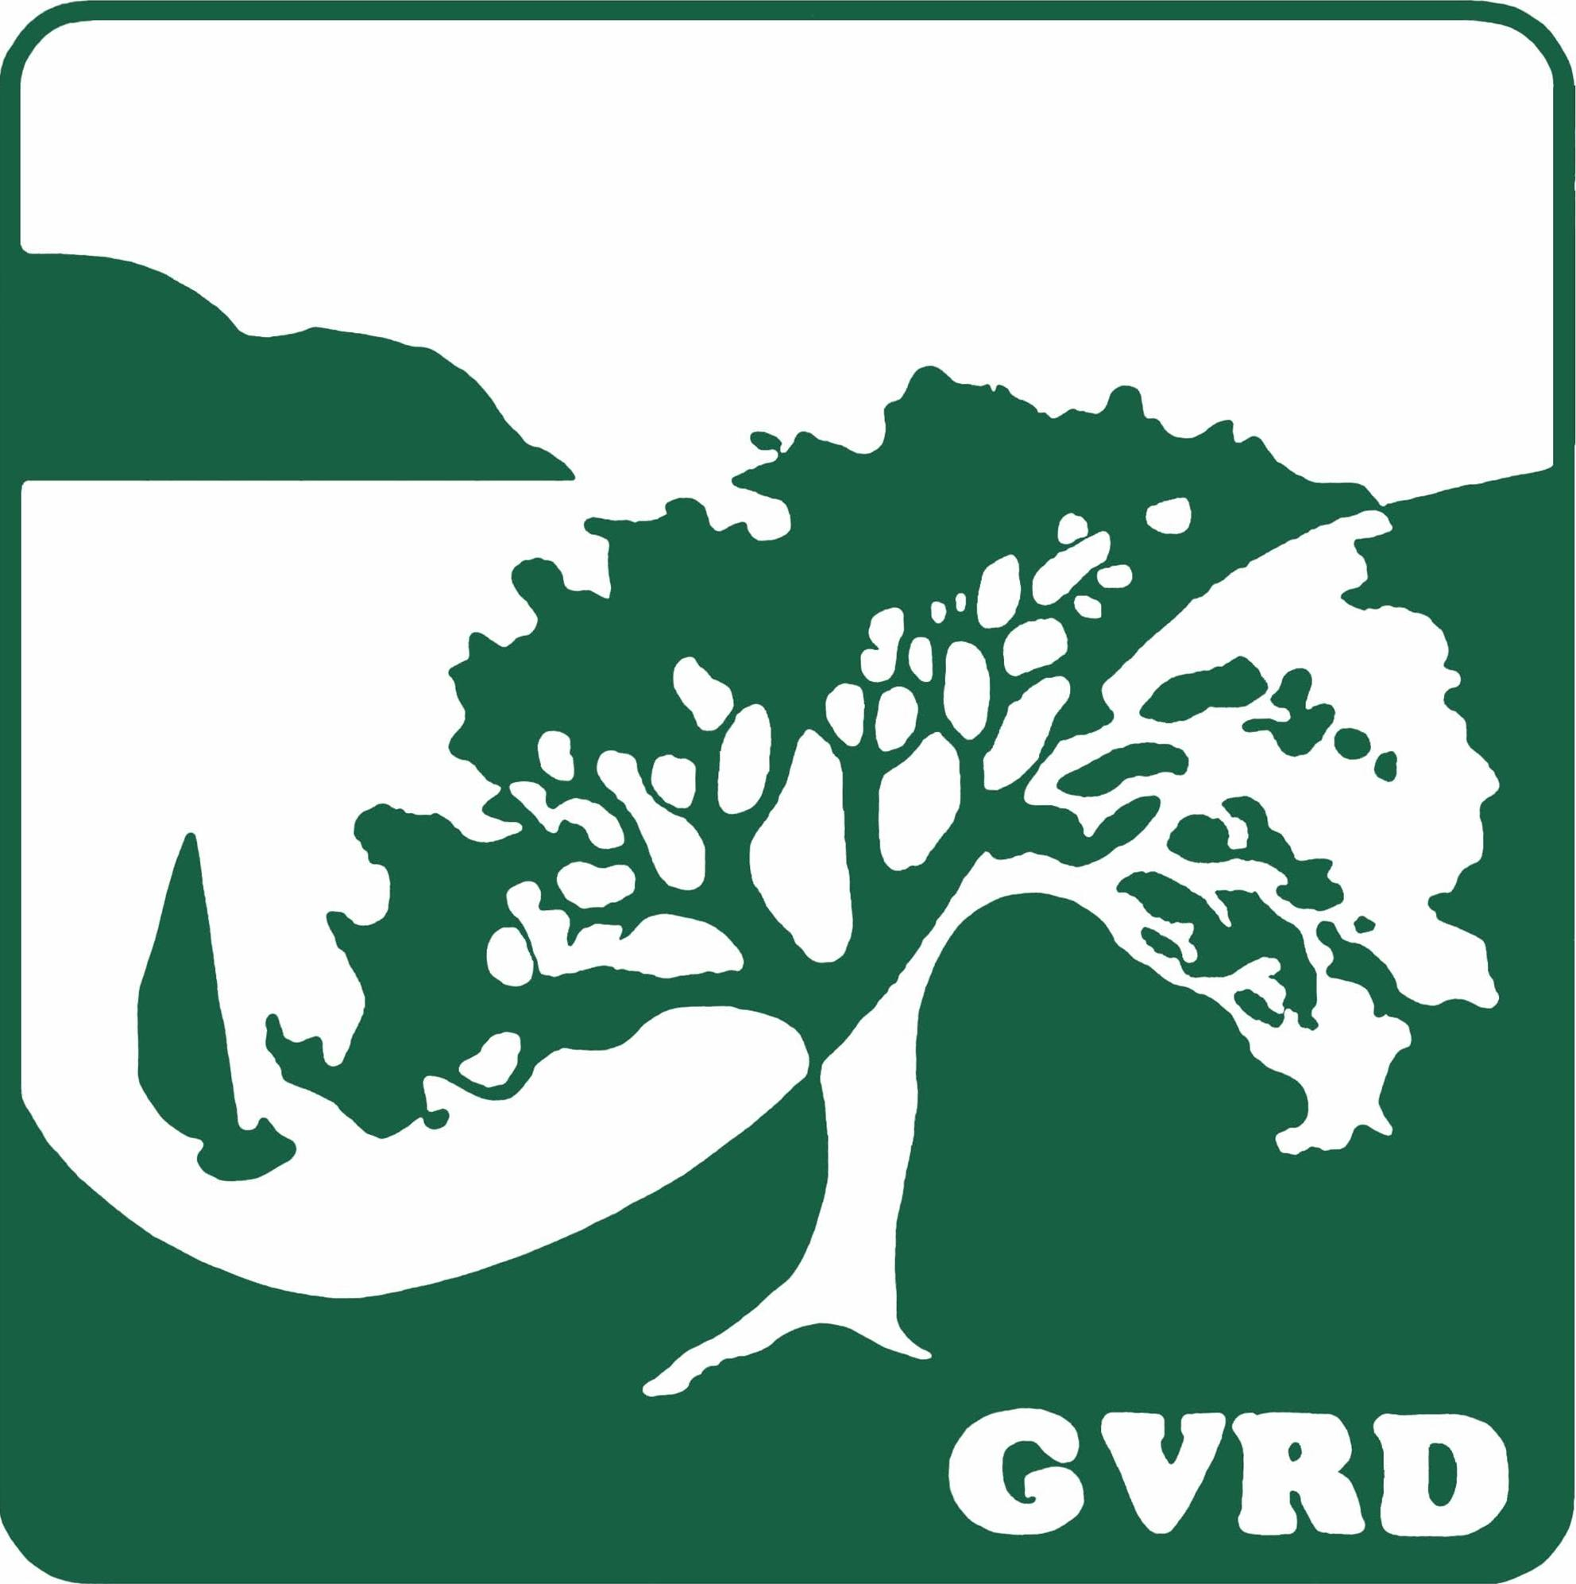

395 Amador Street, Vallejo, CA 94590-6320 707-648-4600 FAX 707-648-4616

Board of Directors
Robert Briseno
Gary Salvadori
Ron Bowen
Sheryl Pannell Lea
Adjoa McDonald

General Manager
Gabriel Lanusse

In accordance with California Government Code Section 54957.5, any writing or document that is a public record, relates to an open session agenda item and is distributed less than 72 hours prior to a regular meeting, will be made available for public inspection in the District offices during normal business hours. *Due to the current closure of the district office, documents will be available electronically at https://www.gvrd.org/about-us/agendas-minutes/

Greater Vallejo Recreation District Board of Directors
SPECIAL MEETING AGENDA
April 29, 2021
6:30 p.m.

Due to Solano County and the State of California’s shelter in place orders our Board Meeting will be held remotely via Zoom Meetings (The Zoom platform is ADA compliant)
The public may attend and make a public comment by visiting: https://zoom.us/j/622641170
You may also call in at +1 669 900 9128 US - Meeting ID: 622 641 170
At the beginning of the remote meeting the Board Clerk will ask if anyone wishes to comment on either a specific agenda item or an item not on the agenda but within the jurisdiction of the board. If you need assistance or have questions, please call Kimberly Pierson at 707-648-4604.

- Call to Order

- Pledge of Allegiance

- Roll Call

- Approval of Agenda

- Public Comment:
Members of the public may speak on any item not on the agenda but within the jurisdiction of the Board. Items on the agenda can be addressed at the time the matter is taken up. Each speaker is limited to 3 minutes and a spokesperson for an organization is limited to 5 minutes.

- New Business:
- Board Member Appointments to the Schools and Youth Task Force
- 2021-22 Preliminary Budget Review (Harman)

- Announcements and Comments from Board Members:

- Meeting Adjourn:

Next meeting: May 13, 2021

